FROM | NAME & TITLE |  | CITY OF  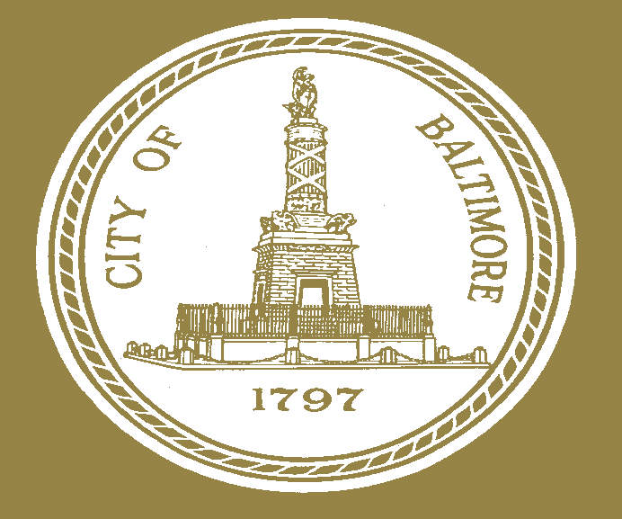  BALTIMORE  M E M O
 | AGENCY NAME & ADDRESS
 | SUBJECT

TO DATE:

28-1418-5017 1400-10-53

